Transforming refugee settlements into
regenerative communities
Annual Biochar Report 2025

Project title: Biochar for Soil Regeneration (Bio-Soil)
Reporting period: July – December 2025
Place of project implementation: Nakivale Refugee Settlement / Uganda
- About the Project
This project addresses the challenges of degraded soil, climate variability, and limited agricultural productivity in the Nakivale refugee settlement. Through a focused approach on biochar production, the initiative involves converting agricultural waste (such as maize stems and other biomass) into biochar using pyrolysis techniques, mixing it with organic materials like compost and goat dung, and applying it to demonstration sites and community farms. This enhances soil fertility, improves water retention, and promotes sustainable farming.
Three demonstration sites were established or utilized in areas like Kabazana A & B, and Kigali village, serving as models for regenerative agriculture. The project also includes training sessions for refugees and host community members to build skills in biochar production and application, reducing reliance on chemical fertilizers and fostering environmental resilience.
A biochar system mirrors natural soil-building processes seen in wildfire-charcoal and ancient Terra Preta soils. By carbonizing biomass it produces a stable, porous form of carbon that remains in the soil for centuries, enhances microbial activity, retains nutrients and water, and significantly improves soil structure over time. This initiative promotes sustainable food production, restores soil health, and transforms refugee communities into self-reliant ecosystems.
- Main Objectives:
Enhancing Soil Quality: To produce and apply biochar-compost mixtures to improve soil structure, water retention, and nutrient availability.
Promoting Sustainable Waste Management: To transform agricultural waste (maize stems) into a valuable resource, reducing open burning and natural decomposition that releases greenhouse gases.
Building Community Capacity: To equip farmers and team members with practical skills in biochar production and sustainable land management.
Fostering Innovation: To design and deploy locally-fabricated, efficient biochar production technology (metallic Kon-Tiki kilns).
Enhancing biodiversity and climate resilience: Through diverse applications (e.g., to bananas, maize, and fruit trees) and the use of local biomass, the project supports ecosystem restoration, mitigates drought impacts, and builds resilience against climate challenges.
- Activities Conducted:

Biochar Production and Training: Biochar production was launched following a foundational training in Kigali, Rwanda. The team then established on-site production using earth Kon-Tiki kilns, processing maize stems and other agricultural waste. This initiative yielded a total of 61 sacks of biochar over three months (June-August), demonstrating a scalable model for converting local biomass into a valuable soil amendment. A key adaptation was the scheduling of production sessions during cooler evening hours, which improved safety conditions and operational efficiency.

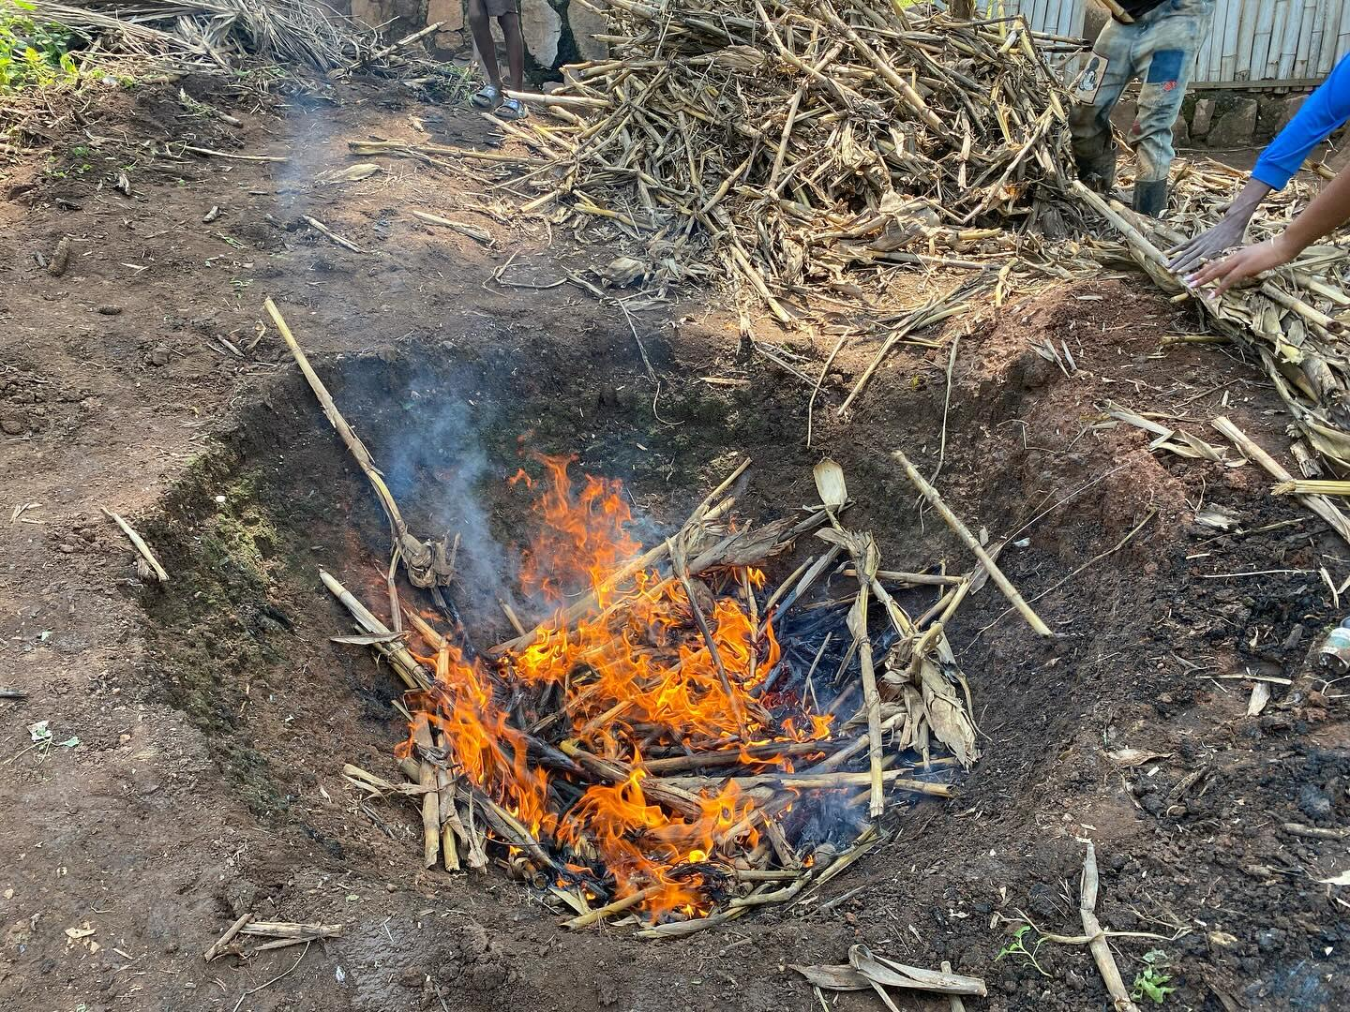

Biomass Collection and Preparation: Surveys identified biomass sources in Kabazana A & B, Misiera, and Kigali village . Teams cut, transported (using tricycles), and dried materials like maize stalks from 31 farms collected addressing termite damage and weather issues.

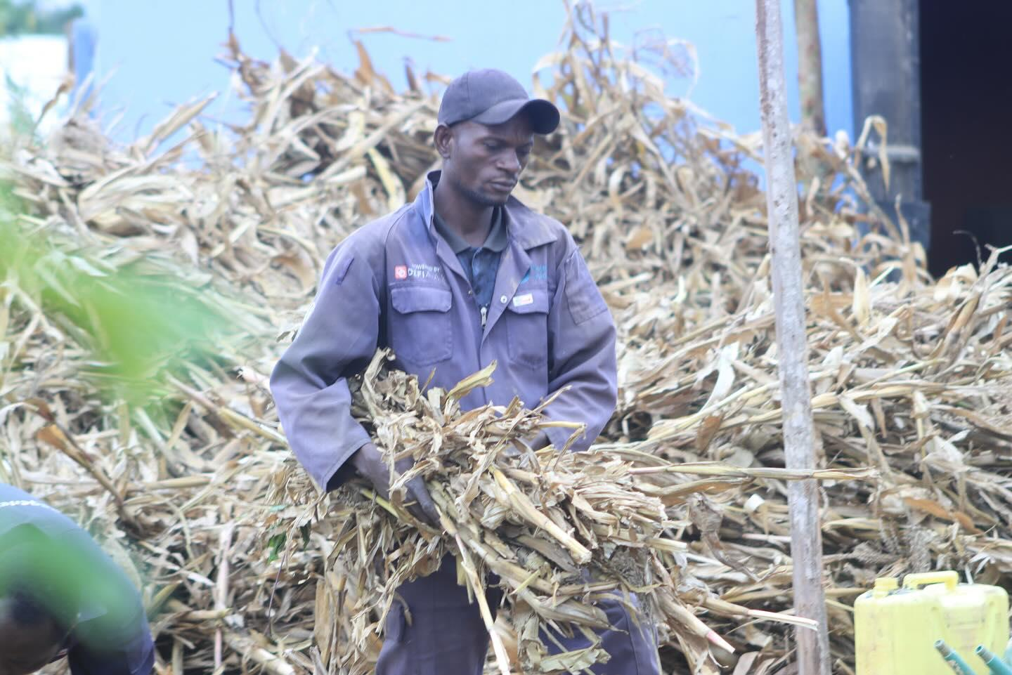

Mixing and Application: Biochar was mixed with compost and goat dung (e.g., 1,900 kg in November) and applied to crops, including maize fields (9 farms planted), 128 banana seedlings, and 23 fruit trees (jackfruit and bull’s heart). Distribution reached 5 beneficiaries directly.

Infrastructure Development: Engaged local welders to fabricate 2 metallic Kon-Tiki kilns, supervised renovations of vermicompost sites and biochar stores, and monitored applications for growth impacts.
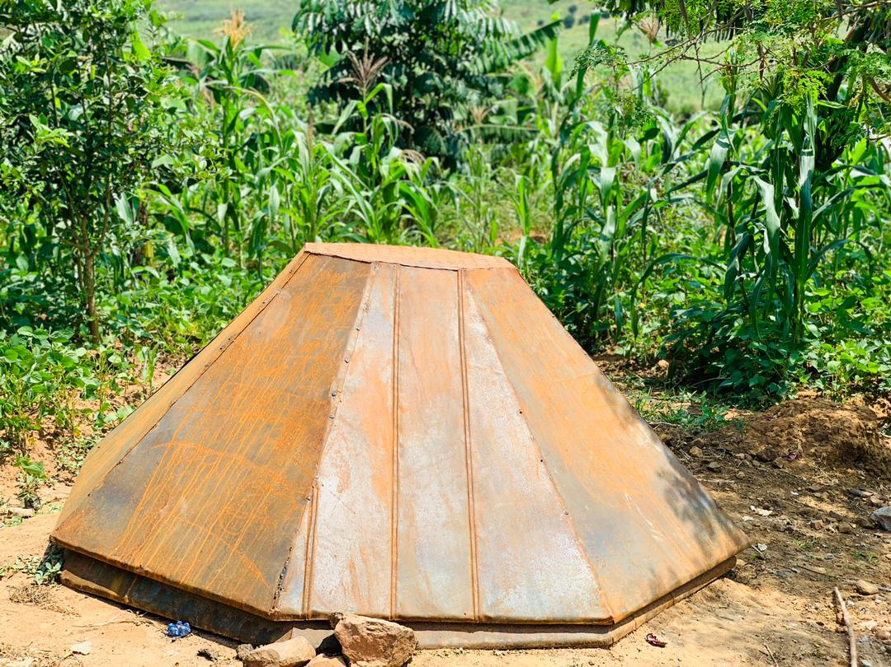
Locally fabricated metallic Kon-Tiki kiln used for biochar production.

- Annual Progress Achieved Toward Planned Outcomes
In 2025, the Biochar Project successfully laid a strong foundation for scalable soil regeneration. A complete biochar production system was established and applied in selected fields, producing encouraging early results. Soil health improvements were observed in treated plots, including better water retention, faster maize germination, and stronger early banana growth. Community capacity also increased, with two team members receiving specialized training in biochar techniques. To assess field performance, the project distributed the biochar–goat dung mixture to five farmers for testing in their gardens, and the final results from these plots are expected by January 2026. Despite drought conditions, treated plots already showed up to 20% higher establishment rates compared to untreated areas.
Indicator Type | Description | Baseline(Start Of 2025) | Annual Target | Actual Progress Achieved By Year End
Output level indicator | Number of metallic kon tikin fabricated and operational | 0 | 2 units | 2 units successfully fabricated, transported, and installed at the Kabazana A site
 | Quantity of biochar produced |  | 6100 kg | A total of 6,100 kg of biochar was produced during the reporting period, of which 1,500 kg remains in storage and will be used in 2026 for new demonstration plots and expansion activities.
 | Number of farmers participating in biochar training & surveys | 0 | 20 | Over 5 farmers were directly engaged in surveys, interviews, and practical training sessions on biochar benefits and applications.
 | Number of demonstration sites actively using biochar | 0 | 3 sites | Application initiated at the Kabazana A, Kigali, Kabazana B demonstration sites and on individual beneficiary plots.
 | Adoption of biochar practices by beneficiaries | 0 | 10farmers | 5 farmers directly applied the biochar mixture to their gardens and provided testimonies on its initial effects.
 | Diversification of biomass use (reduction of open decomposition) | 100% decomposition/burning | 15% reduction | Awareness significantly raised; several farmers now see maize stems as a resource for biochar instead of waste.

- Changes and amendments
Biomass collection required significant adjustments due to environmental and financial challenges. Termite damage and unexpected rainfall repeatedly affected the quality and availability of maize stems, which are essential for biochar production. To overcome this, the team shifted to early sourcing, collecting biomass immediately after harvest and introduced improved storage practices to keep the materials dry and protected. Financial delays in acquiring critical Personal Protective Equipment (PPE) and arranging consistent transportation further slowed operations. As a result, the team adopted evening work sessions, which offered cooler working conditions and improved safety while awaiting the procurement of full PPE. Additionally, rising material costs led local welders to increase their fabrication prices from 350,000 Ugx to 500,000 Ugx, requiring the team to renegotiate and adjust the budget accordingly.
Furthermore, recurring drought conditions significantly reduced the availability of biomass across several villages. Farmers harvested less maize, and crop residues dried too quickly or became too brittle for efficient collection. Some fields had minimal biomass left because plants failed to mature fully under prolonged heat stress. These drought-related shortages required the team to diversify biomass sources such as incorporating goat dung and other dry plant materials to ensure continuous biochar production despite the limited supply of maize stems.
Stories of Change: Farmer Testimonials
A Shift in Practice and Promising Results
As part of our monitoring, we provided five different farmers with the biochar-compost mixture to test in their gardens. Their initial testimonies highlight the practical impact and growing acceptance of this innovation.
Shumbushu Jean de Dieu Kabazana A: "I always left my maize stems to rot in the field, thinking it would help the soil. The team explained that this can harbour diseases and release carbon. I was sceptical about biochar, but after applying the mixture to my spinach and eggplant plot, I noticed the soil stayed moist for longer during a dry spell. The plants also looked greener and healthier compared to my other garden."
Thomas Miburo, Kabazana B: Using the biochar mix was a new experience. I have applied it around my young banana seedlings and cassava. It is too early to see significant yield increases, but the seedlings have not wilted under the strong sun, which is a common problem. This gives me hope for a better harvest.
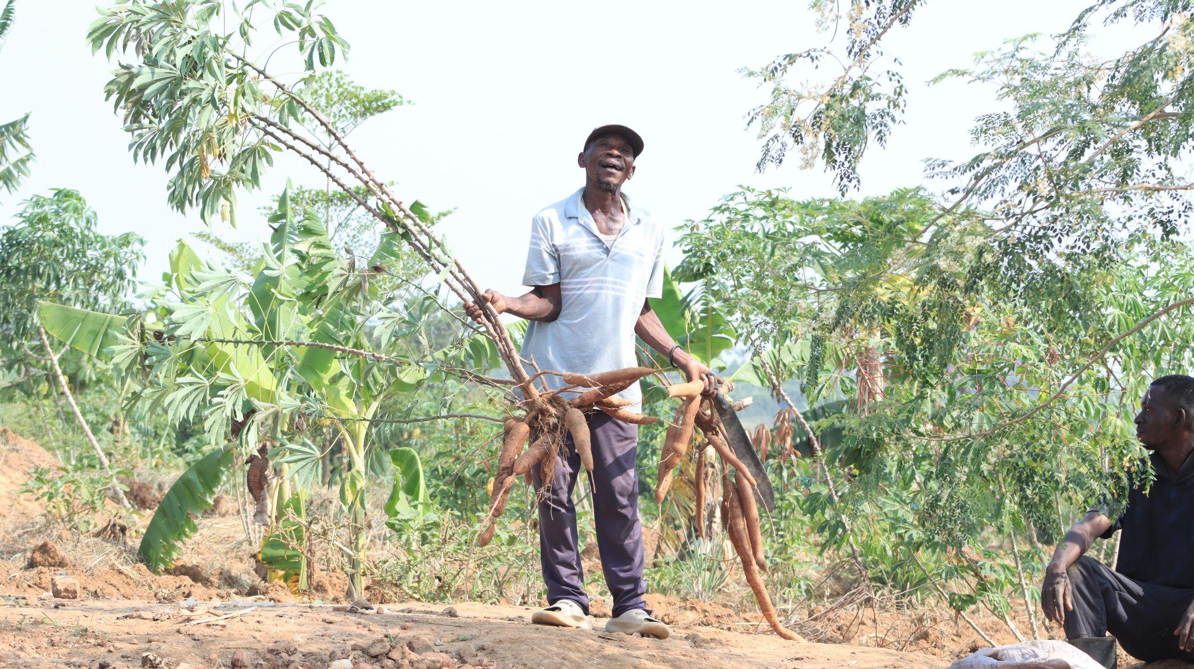
Moses Wani Longa, Kabazana A: "I received the mixture and used it when planting my maize. The germination was faster and more uniform than in the past. I am now telling my neighbours about this 'black gold' and why we should not just burn our farm waste."

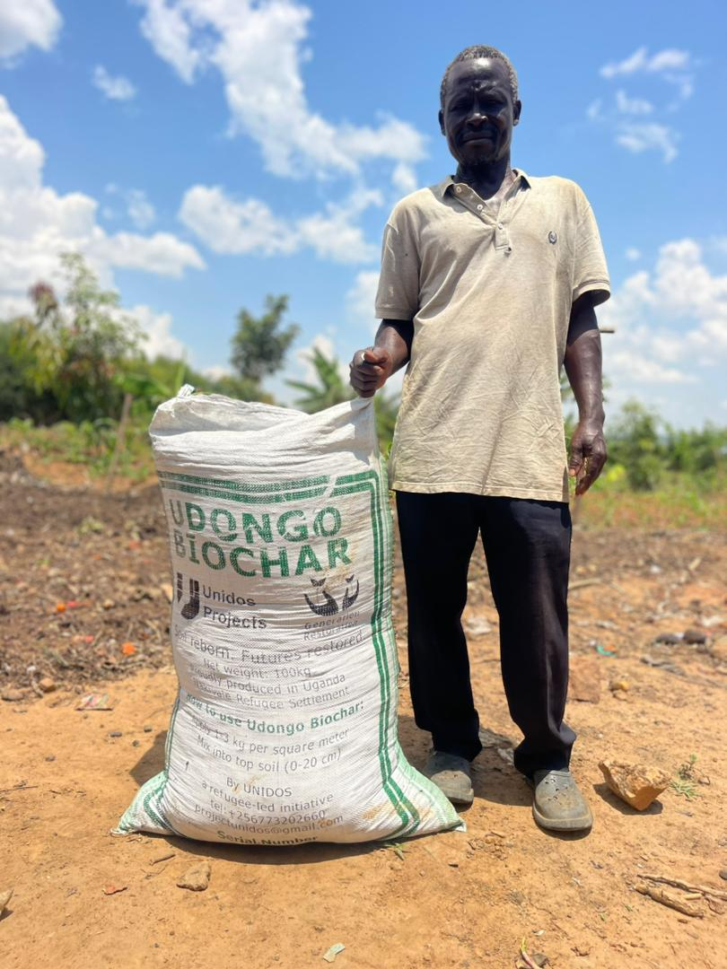
A proud farmer stands with a 100kg bag of Udongo Biochar
These stories underscore a crucial shift: farmers are beginning to see agricultural waste as a valuable input for soil health, moving away from traditional practices towards more regenerative, knowledge-based agriculture.
- Challenges and Adaptations
The project encountered several unforeseen challenges during implementation, including technical and logistical delays caused by prolonged price negotiations with welders and unexpected power outages that slowed the fabrication of the metallic Kon-Tiki kilns. Resource limitations such as insufficient PPE, transport breakdowns, and inconsistent availability of maize stems also affected production because we delayed the collection due to financial issues.
Environmental factors further complicated operations, with heavy rainfall disrupting production schedules and biomass drying, while extreme heat reduced productivity during fieldwork. In response, the team adopted practical adaptations by rescheduling transport during drier periods, renegotiating costs with local artisans, organising evening work sessions to avoid excessive heat, and prioritizing the purchase of essential safety equipment to ensure continuity and protect staff.
6. Lessons Learned
The project highlighted that community engagement is fundamental, as direct interaction and practical demonstrations are crucial for helping farmers shift away from long-held traditional practices, with farmer testimonials proving especially effective in building trust. It also became evident that locally fabricating the kilns through community welders fosters strong ownership, supports the local economy, and ensures the technology remains easy to maintain and repair.
Additionally, the experience underscored the importance of proactive logistics such as planning for transport, biomass storage, and weather disruptions to keep activities running smoothly. Finally, the project reaffirmed that safety must remain a top priority, as fieldwork involving fire and biomass handling requires strict adherence to PPE use and safety protocols to protect the entire team..
- Innovation
The Biochar project introduced an innovative circular economy model in Nakivale by transforming agricultural waste into a valuable resource for soil regeneration. Through the development of affordable, locally made metallic Kon-Tiki kilns and the creation of a biochar with vermicompost mixture, the project demonstrated a practical and low-cost solution that farmers can adopt. This approach improves soil health, reduces dependence on external agricultural inputs, and empowers the community with a self-sustaining, regenerative technology.
- Next Steps and Recommendations for 2026
To enhance the impact of the initiative, production will be scaled up by fully utilizing the two operational kilns for continuous production, while expanding the application of biochar mixtures to additional farms and a wider range of crops across the settlement.
A formal monitoring system will also be established to collect and analyse data on soil health and crop yields, enabling evidence-based evaluation of results over time.
Strengthening partnerships with organisations specialising in agricultural tools and renewable energy will further boost production capacity and efficiency. Additionally, a community-led expansion model will be promoted by training 100 champion farmers to serve as biochar producers or biomass collectors, encouraging peer-to-peer learning and broader adoption of the practice.
As the project enters 2026, it carries forward 1,500 kg of biochar in reserve, providing a ready supply for early-season planting and supporting the planned expansion to new farms. We aim to produce at least 40 tons of biochar next year and explore the possibilities to expand or scale the production in host communities.

